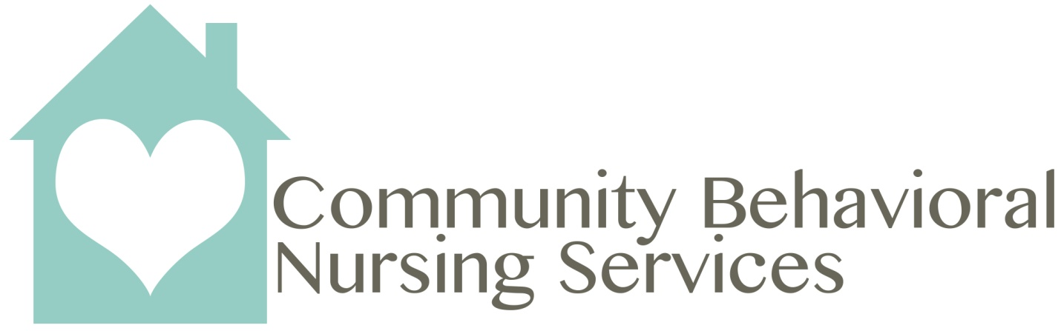
Do you want a job with a flexible set schedule, one on one interactions with patients, and one where you leave feeling like you are truly making a difference? If so, Community Behavioral Nursing Services is waiting for you. CBNS is a home health agency that serves the Developmentally Disabled population. We are currently hiring LPN’s and RN’s in the following areas:
- Berea – Two full-time positions
- Strongsville – One full-time position
- Mentor - Two full-time positions
- Euclid – Two part-time positions
- Cuyahoga Falls/Munroe Falls - Two full-time positions

Responsibilities:
- Provide one on one skilled nursing care to our patients
- Performing assigned duties, including administration of medication, wound care, treatments, and procedures
- Oversees the implementation of the patient's plan of care. Evaluates the effectiveness of the plan on an ongoing basis
- Prepare medical documentation on all patients, may include case conferences, patient contacts, medication order changes, re-certifications, progress updates, and care plan changes. Prepare visit/shift reports, updates/summarizes patient records, communication notes and confers with other health care disciplines in providing superb patient care
- Act as liaison between staff, patients, physicians, and other health care providers
- Helps decrease re-hospitalizations by providing education on preventative measures

Requirements:
- Active, valid, and unencumbered License for the State of Ohio.
- Experience in Home Health Care preferred.
- Experience with electronic charting and EVV is helpful.
- Flexibility in schedule and desire to work as a team.
- Able to work split shifts; 5:30am - 9:30am, 3:00pm - 9:30pm (M - Thurs) and 5:00pm - 9:30pm (Fri - Sun) - times may vary by location.
- Must be available to work a set schedule - 3 days one week and 4 days the second week, every other weekend, and rotating holidays. I am hiring for the M/W rotation.

Work Schedule:
- Week 1: Saturday (AM and PM), Sunday (AM and PM), Mon (AM and PM) and Wed (AM and PM)
- Week 2: Mon (AM and PM), Wed (AM and PM) and Fri (AM and PM)

Benefits of Working at CBNS:
- Nursing assignments are less than 10 -15 miles from each other
- Set schedules for nurses. Nurses get every other weekend off
- Full-time nurses receive medical benefits. CBNS offers paid time off and paid holidays
- Nurses are supplied with Verizon tablets for charting
- Employee referral program

